Columbus Primary Sources

Relationship with Crew
On August 6th 1492, the rudder of our ship the Pinta broke! I think people on the ship might have done it. My sailors Gomez Rascon and Christopher Quintero were both on board and have complained about this trip.
-August 6th, 1492

We sailed more than 60 miles, but I’m not telling my crew the truth because they seem very worried about if we will ever find land. The sailor steered our ships badly, causing them to tip a lot. I had to tell him repeatedly to do better.
-September 9th, 1492

The little fleet of ships, the Nina, Pinta and Santa Maria left on Aug. 3, 1492. The admiral's navigational genius showed itself immediately, for they sailed south to the Canary Islands , off the northwest African mainland, rather than sailing due west to the Azores . The westerlies (strong winds) in the Azores had defeated previous sailors to the west, but in the Canaries they could pick up the northeast trade winds, trusting to the westerlies for their return. After nearly a month in the Canaries the ships set out from the harbor on September 6. On October 12 land was sighted from the Pinta (though Columbus, on the Niña, later meanly claimed the privilege for himself).
-November 3rd, 1492

Relationship with Catholic Church
I, pope Alexander VI, leader of the Catholic Church, give Christopher Columbus all the lands you discover. I will let you own them.
-Pope Alexander, May 4, 1493

Your Highnesses, as Catholic Christians, send I, Christopher Columbus, to the parts of India, to see those far away people and lands and allow me to bring about their conversion to our holy faith. You have already driven the Jews out from places you rule and, with a sufficient fleet, I would like to go to said parts of India, and be High Admiral of the Sea, and perpetual Governor of the islands and continents which I might discover…and that my eldest son should succeed to the same position, and so on from generation to generation.
-August 2, 1492, Columbus wrote this entry into his journal.

King and Queen of Spain, my name is Christopher Columbus. Since you love Christianity and don't love enemies or people who aren't Christian, please send me to India. I want to meet with the people and see the land there. I want to help make them Christian. If I find this land and meet these people, then I want to rule it.
-On August 2, 1492, Columbus wrote this entry into his journal.

Relationship with Spanish Monarchy

To pay for this trip, I want you, Christopher Columbus, to take all the pearls, gold, silver, spices and other expensive things. And then, I will give you a part of it all.
-King Ferdindand and Queen Isabella of Spain, 1492
King and Queen of Spain, you would not believe how kind, generous, and loving these Indians are! If you ask them for something, they will give it. I will give you, the King and Queen of Spain, as much gold as I can get and as many slaves as I can take on the ship.
- On April of 1493, Columbus wrote this letter to a financier, Luis de Santangel.

Relationship with Taino Indians

On the thirty-third day after leaving Cadiz I came to the Indian Sea, where I discovered many islands inhabited by neumerous people. I took possession of all of them for our lucky King by making a public statement and unraveling his flag. None of the Taino Indians made any resistance.
- 1493
I ordered every Indian over fourteen to collect three handfuls of gold every three months. I'm going to give this to the King and Queen of Spain. When the Indians bring it, I give them a copper necklace. Those Indians who don't do this will be punished.
- April 14th 1495,

Christopher Columbus Character Analysis
Directions: Describe Columbus’s relationship with each of the following using the documents and infer why his relationships were characterized this way. Be descriptive and specific!
The Tanio Indians
The Spanish Monarchy

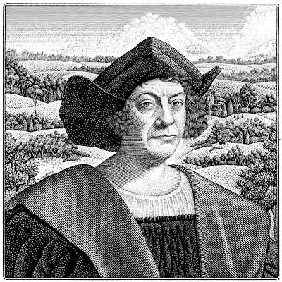

The Catholic Church
The crew of his ships

